Criminal Arsenic Poisoning-A Case Report

Pawan Mittal^{a*}, Dinesh Chhillar^{b}, S.K. Dhattarwal^{c}, Kamal Singla^{b}, Vincent Merry^{b}, Sonia Singh^{d}

Demonstratorª, Resident^{b}, Senior Prof. & Head^{c}
Department of Forensic Medicine & Toxicology
Resident^{d}, Deptt. of Pathology
Pt. B.D. Sharma Post Graduate Institute of Medical Sciences
University of Health Sciences, Rohtak (Haryana)

*Correspondence: drmittalpawan@gmail.com; +91-9996031331
………………………………………………………………………………………………………

ABSTRACT
Arsenic has been considered as an ideal homicidal poison from centuries back till date and placed in the top list of lethal poisons used with criminal intent. The present case exemplifies a similar typical case of criminal arsenic poisoning. The autopsy findings of red velvety gastric mucosa, petechial haemorrhages over epicardial and endocardial heart surfaces, scalp and over visceral organs along with the typical clinical profile of the deceased lead to a strong suspicion of arsenic poisoning which were further confirmed by histopathological findings and the circumstantial evidence.
KEYWORDS: Arsenic, Homicidal poisoning, Petechial haemorrhages, Velvety-red mucosa,
- INTRODUCTION:
For centuries arsenic has been used for homicidal and very rarely suicidal purposes. Arsenic is a metalloid that exists as elemental, gaseous, organic and inorganic form. Inorganic arsenicals exist in trivalent and pentavalent states. The acute toxicity of an inorganic arsenic compound depends largely on its solubility, and on whether the compound is ingested in a dissolved or undissolved form.[1] Trivalent arsenicals are more toxic than the pentavalent forms.[2] Arsenic trioxide is a trivalent arsenical, commonly known as white arsenic (sugar like appearance) and has been called “poison of poisons”. It has been used advantageously as homicidal agent for being colourless, tasteless and odourless, small lethal dose (even a pinch weighing 20 gms will kill 8-10 persons), easy availability, cheap price, easy administration with food or drink, gradual onset of signs and symptoms (resemble those of cholera) and certainty of action.[3]
The signs and symptoms of acute arsenic poisoning may appear in: (a) fulminant form, (b) gastroenteric type (common form) or (c) subacute narcotic form.[4] It is absorbed through all portals of entry including oral, inhalational and cutaneous routes. After absorption it is redistributed to the liver, lungs, intestinal wall, and spleen, where it binds to the sulfydryl groups of tissue proteins that account for its cytotoxicity by interfering with cellular respiration. More than 90% of an ingested dose of dissolved arsenic trioxide is absorbed in the gastrointestinal tract.[5,6] About 180 mg of arsenious oxide is the average fatal dose. The smallest amount known to have caused death is 125 mg. Recovery has taken place after much larger doses, varying from 4 g to 60 g, but these are exceptional cases.[7] The pathoanatomic findings in case of arsenic poisoning may vary depending upon the survival period of the patient. These may range from slight mucosal hyperemia to profound multiorgan damage.
The present case justified all the circumstances, typical of homicidal arsenic poisoning that was further confirmed by the autopsy, pathological and circumstantial investigations.

- CASE PRSENTATION:
The case relates to a 38 years old thin built male (figure 1) who was called on an evening to in-laws house, to discuss some family disputes. Purportedly the couple was living in separation on account of some long running property affairs between them. The person was offered a cup of hot tea there. After having the tea, on certain dispute over there, he again has a quarrel with the wife and in-laws and left from there. On the way, the patient felt some discomfort in the chest and burning sensation in the abdomen with palpitation along with a feeling of choking. After reaching home (after about 2 hours) he had an episode of projectile vomiting with brownish vomitus and watery diarrhea. The patient himself and the relatives got suspicious that the lady and in-laws have poisoned him. The patient denied of any suspicion of poison in the tea by odour, taste or colour. He was immediately admitted to the dep’t of Accident and Emergency PGIMS, Rohtak.
The patient presented with pulse and blood pressure unrecordable and altered sensorium. The gastric lavage was done which revealed only small amount of brownish-red fluid material. The ECG revealed ventricular tachycardia with prolonged QT interval and ST segment depression. The patient was treated on all best possible grounds with inotropes, defibrillation and mechanical ventilation, but was not revived and declared dead after about 6 hours of presentation.
Next day the dead body was brought for autopsy to the dep’t of Forensic Medicine PGIMS, Rohtak, under section 302 of the Indian Penal Code (punishment for murder) with the complainant being the brother and the accused being the wife and in-laws of deceased. The apparent cause of death as stated by the police was “administration of poison by other person”. The chief autopsy findings were:
- External Examination:
The rigor mortis was well developed all over the body. Post mortem lividity was purplish-red and fixed. Conjunctival congestion was present bilaterally. Whitish slightly viscid mucoid secretions were present around mouth and nostrils.
- Internal Examination:
Internal examination revealed findings of asphyxia (non-specific but known to arsenic poisoning) and specific to acute arsenic poisoning. All the viscera were markedly congested. The stomach was containing about 50 ml of reddish-brown fluid material. The gastric mucosa was haemorrhagic patchily and showed generalized congestion that was more marked along the gastric rugae. The mucosa was pulpy and oedematous on touch and red velvety in appearance (figure 2). Slight garlicky odour from the mucosa could be well appreciated. The surface of heart showed showers of pinpoint to pinhead size epicardial haemorrhages distributed chiefly over left ventricular posterior wall (near atrioventricular groove) and over base involving anterior surface of left ventricle and ascending aorta (figure 3, 4). Slight left ventricular and septal hypertrophy with subendocardial haemorrhages over the valve cusps and chordae tendinae was present (figure 5). Liver, spleen and kidneys were markedly congested. Gall bladder was distended with bile. The lungs were oedematous and showed numerous petechiae chiefly in interlobar fissure regions with subpleural ecchymotic patches at places. Scalp was studded with petechial haemorrhages (figure 6). The brain was congested and oedematous and showed numerous petechial intracerebral haemorrhages chiefly in the region of basal ganglia. Urinary bladder was empty while its mucosa was congested.
The histopathology of various organs revealed hepatocyte ballooning degeneration with marked sinusoidal congestion in the liver, patchy pancreatic necrosis with mild lymphomononuclear infiltrate and congestion of the spleen and kidneys. Mild left ventricular and septal hypertrophy was seen. Lungs revealed necrotizing epithelioid cell granulomas with ZN staining for AFB positive suggestive of tuberculosis (an incidental finding). The circumstantial evidence including the police interrogation revealed confession of the wife and relatives regarding the criminal administration of arsenic in hot tea.
- DISCUSSION:
Arsenic is used homicidally much more frequently in India than in any other country, as it is cheap, easily obtained in every town and easily concealed in the food as a consequence of its freedom from smell and taste. It has had an outstanding reputation as an ideal homicidal poison in the west also, particularly United Kingdom in the Victorian era. Murder of one of the most celebrated Napolean Bonaparte has been established scientifically beyond reasonable doubts due to arsenic poisoning. The ease with which arsenic trioxide can be easily administered without raising suspicion is on account of almost tasteless, odourless and colourless properties of this poison. Though solubility is the chief hindrance in its use but the same is greatly enhanced if hot solution such as tea, coffee, cocoa, porridge or gruel etc. are used.[8]
Mass homicidal poisoning in which persons have been affected has sometimes occurred from arsenic having been administered by an individual in some article of food. Arsenic is used occasionally for suicidal purposes, but owing to severe pain caused by its injection, suicide victims resort to this poison much less than opium. Accidental cases of poisoning by arsenic sometimes occur from its admixture with drink or articles of food, or from its improper medicinal use. Multiple accidental cases may also occur from drinking water from streams containing arsenical mineral deposits.[7]
Acute arsenic poisoning leads to usually pronounced gastrointestinal symptoms due to dilatation of splanchnic vessels resulting in submucosal vesicle formation. The patient develops nausea, vomiting, diarrhea (which may be bloody), and abdominal pain. A garlicky breath odor may be detectable. Gastrointestinal involvement can cause fluid loss and hypotension. Subsequently, a protein-losing enteropathy may develop. Arsenic also induces increased hepatocytic mitotic activity, which is likely to be related to the mitogenic properties of arsenic.[9] Electrocardiographic findings may include QRS complex broadening, QT prolongation, ST-segment depression, T-wave flattening, and multifocal ventricular tachycardia.
Anatomic changes from fatal inorganic arsenic poisoning by oral intake are hemorrhages and ulcers of the gastrointestinal tract, hepatocellular necrosis, renal tubular necrosis, pulmonary edema and emphysema, and subendocardial hemorrhages with interstitial myocarditis The shorter the survival interval, the less prominent the anatomic changes and vice versa. In hyperacute poisonings anatomic changes will be essentially negative or restricted to gastric mucosal hyperemia.[10] In the present case, the autopsy and histopathological findings agreed well with the survival interval.

- CONCLUSION:

Arsenic compounds have been used for both therapeutic and malevolent purposes since 3000 BCE. Being thought to occur throughout the universe and the twentieth most common element on the earth, arsenic is today the commonest source of acute heavy metal poisoning and is second only to lead in the incidence of chronic toxicity. However the popularity of arsenic has declined in the recent times because of various factors and today most cases of arsenic poisoning are accidental though murders are still reported from time to time, as was reported in the present case.

- REFERENCES:

- World Health Organization. Arsenic. Geneva 1981.(Environmental health criteria 18).
- Byron WR, Bierbower GW, Brouwer JB, Hansen WH. Pathologic changes in rats and dogs from two-year feeding of sodium arsenite or sodium arsenate. Toxicol Appl Pharmacal 1967;10:132-47.
- Mukherjee JB. Forensic medicine and toxicology. 4th ed. Kolkata: Academic Publisher; 2011: p. 356-7.
- Reddy KSN. The essentials of forensic medicine and toxicology. 32nd ed. Hyderabad: Om Sai Graphics; 2013: p. 510.
- Pomroy C, Charbonneau SM, McCullough RS, Tam GKH. Human retention studies with ⁷⁴As. Toxicol Appl Pharmacol 1980;53:550-6.
- Vahter M, Marafante E. Intracellular interaction and metabolic fate of arsenite and arsenate in mice and rabbits. Chern Biol Interact 1983;47:29- 44.
- Mathiharan K, Patnaik AK, editors. Modi’s medical jurisprudence and toxicology. 23rd ed. New Delhi: Lexis Nexis Butterworths; 2006. p. 114, 124-5.
- Pillay VV. Modern medical toxicology. 4th ed. New Delhi: Jaypee Brothers Medical Publishers (P) Ltd; 2013. p. 82.
- Bernard R, et al. Increase Hepatocytic Mitotic Activity as a Diagnostic Marker of Acute
Arsenic Exposure. A report of two cases, J Hepatol 1996;25:218-20.
- Adelson L. The pathology of homicide. Charles C Thomas. Springfield IL; 1974: p. 821-35.

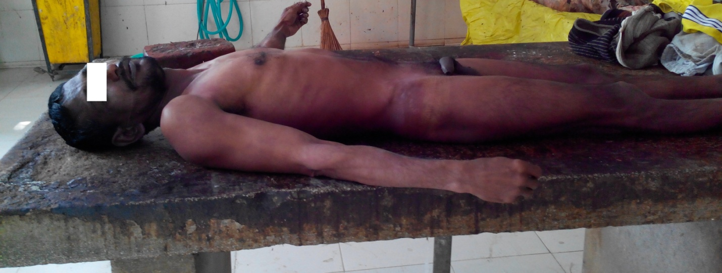

Figure 1: The Victim

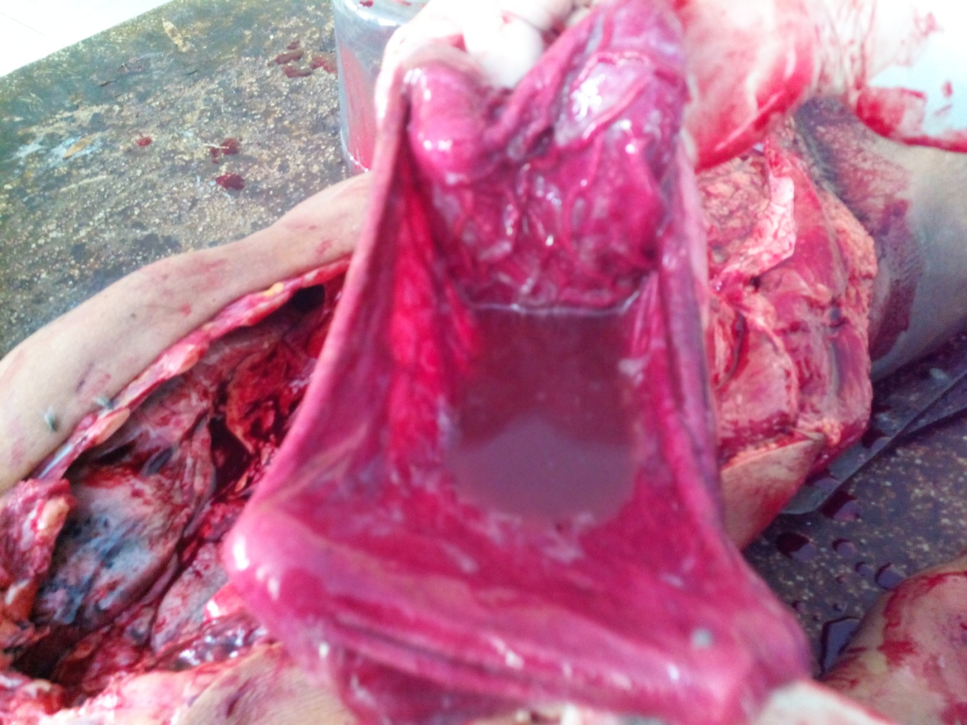

Figure 2: Valvety-red gastric mucosa with brownish-red contents

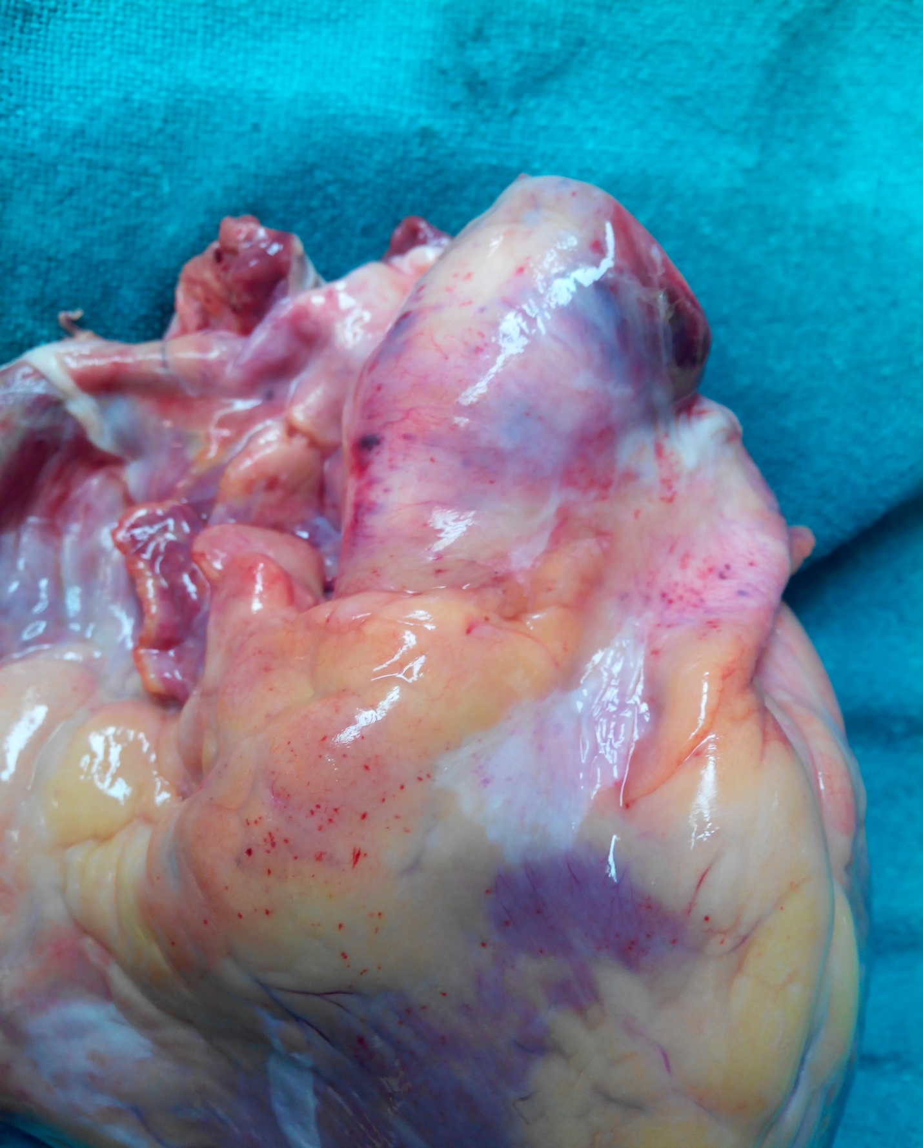

Figure 3: Fine pinpoint shower of epicardial haemorrhages over left anterior atrial-ventricular and aortic surfaces
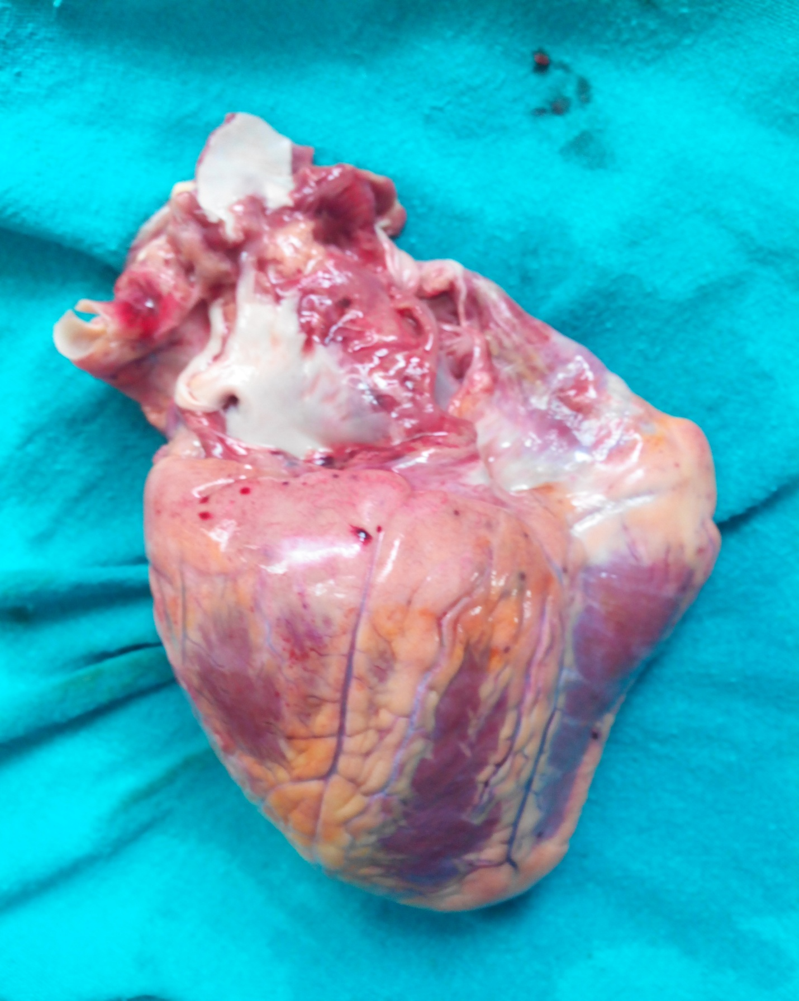

Figure 4: Petechial haemorrhages over posterior ventricular surface

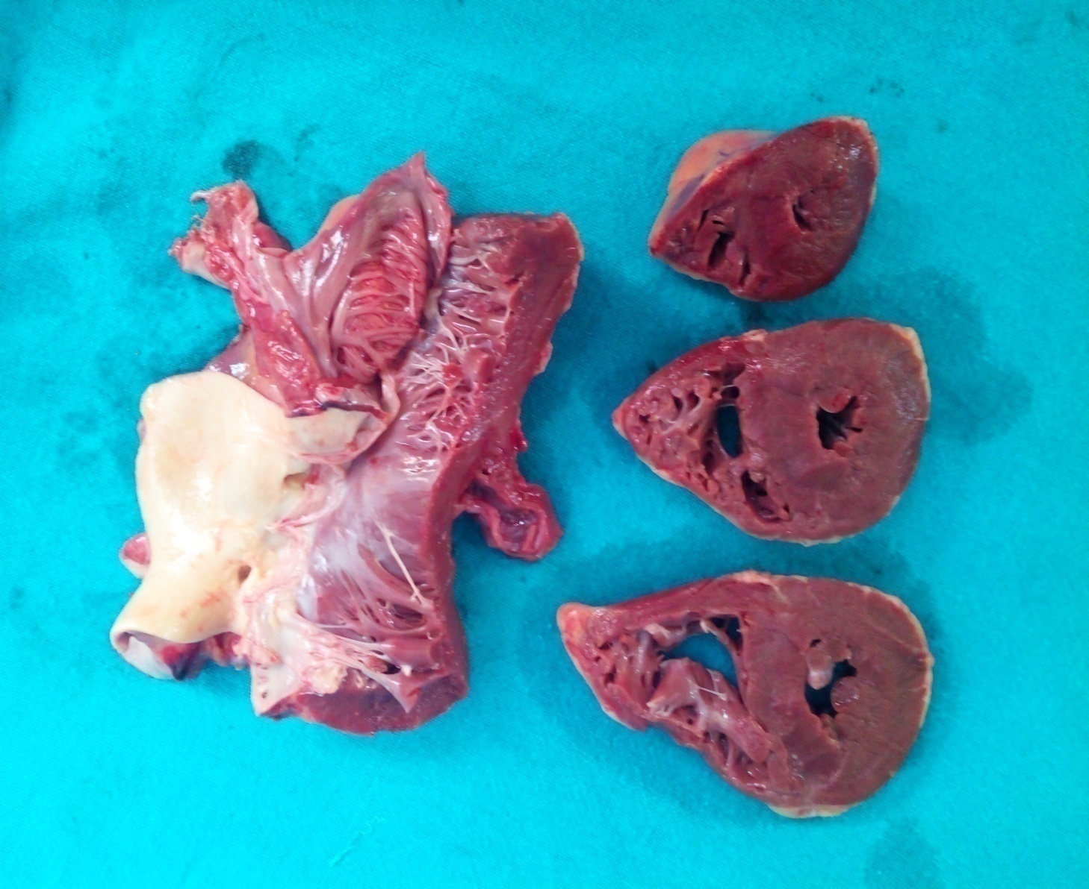

Figure 5: Subendocardial haemorrhages over valve cusps and chordae tendinae. Left ventricular and septal hypertrophy is present

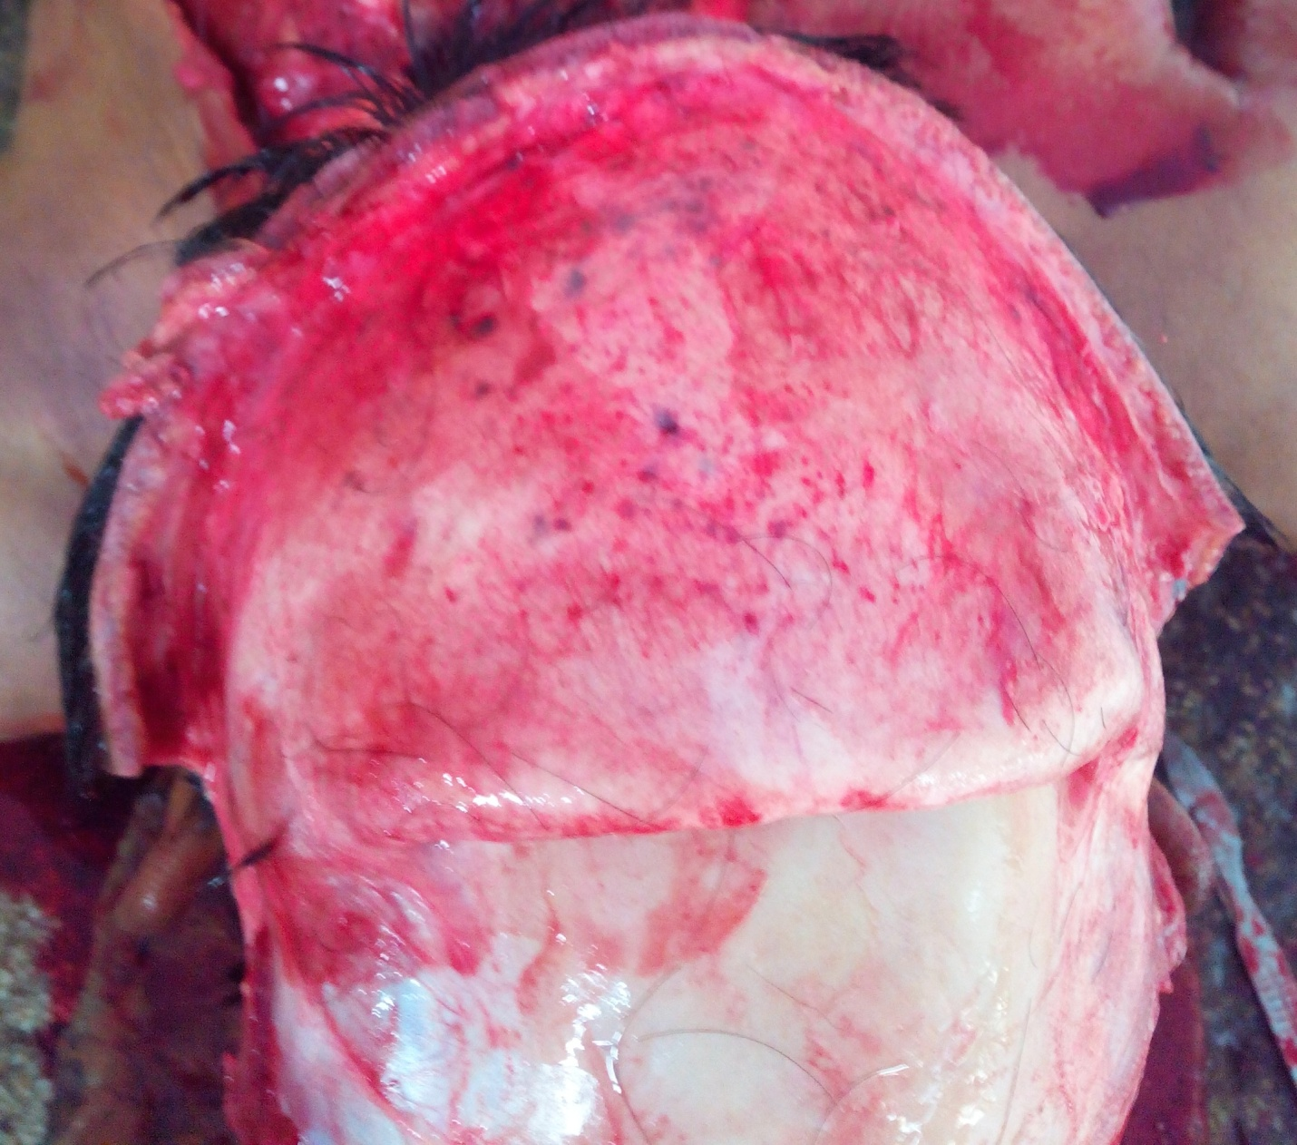

Figure 6: Petechial haemorrhages over scalp

